Q1: The pipelined RISC-V processor is running the following code snippet. Which registers are being written and which are being read on the fifth cycle? Recall that the pipelined RISC-V processor has a Hazard Unit. You may assume a memory system that returns the result within one cycle.
addi s1, zero, 11 # s1 = 11
lw s2, 25(s0) # s2 = memory[s0+25]
add s3, s3, s4 # s3 = s3 + s4
or s4, s1, s2 # s4 = s1 | s2
lw s5, 16(s2) # s5 = memory[s2+16]
Cycle | Fetch | Decode | Execute | Memory | Writeback

Registers Values:

Q2: Using a diagram similar to Figure 7.57, show the forwarding and stalls needed to execute the instructions given below on the pipelined RISC-V processor.

addi s1, zero, 11 # s1 = 11
lw s2, 25(s1) # s2 = memory[36]
lw s5, 16(s2) # s5 = memory[s2+16]
add s3, s2, s5 # s3 = s2 + s5
or s4, s3, t4 # s4 = s3 | t4
and s2, s3, s4 # s2 = s3 & s4
Use following diagram notation to draw solution of Q2
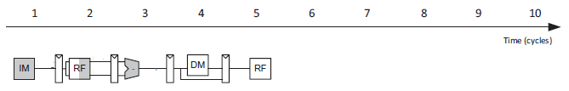

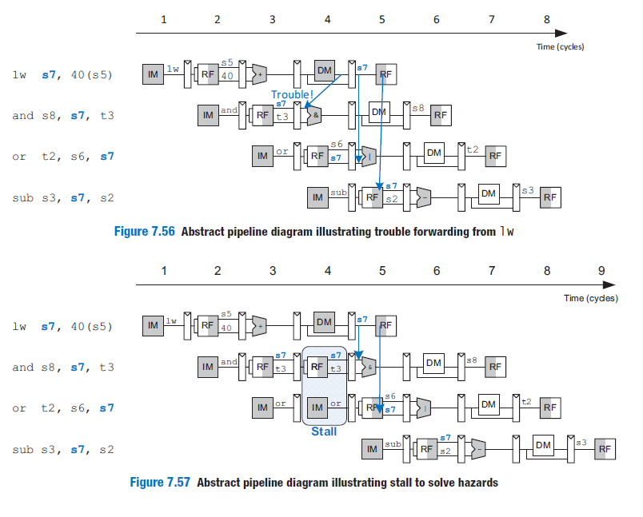

Q3: Consider the following instruction sequence in RISC-V assembly language:
L1: lw x18, 0(x5) # x18 = s2, x5 = t0
sub x18, x18, x19 # x19 = s3
add x5, x18, x19
and x5, x5, x6 # x6 = t1
addi x7, x5, -1 # x7 = t2
beq x7, x0, L1
add x28, x5, x18 # x28 = t3
- Show the timing diagram of the above instruction sequence for a 5-stage RISC-V pipeline (IF, ID, EX, MEM, WB): without any forwarding but assuming a register read and a write in the same clock cycle “forwards" through the register file.
How many cycles does this code sequence take to execute one iteration?
Instruction | CC1 | CC2 | CC3 | CC4 | CC5 | CC6 | CC7 | CC8 | CC9 | CC10 | CC11 | CC12 | CC13 | CC14 | CC15 | CC16 | CC17 | CC18 | CC19

- Show the pipeline timing assuming full forwarding is enabled and register file supports same-cycle read/write. Show the forwarded values and indicating stalls; i.e, by circling or drawing clouds as well as labeling the instructions. Hint: recall that stalling does not use NOP instructions.
How many clock cycles are required for one iteration now?
Instruction | CC1 | CC2 | CC3 | CC4 | CC5 | CC6 | CC7 | CC8 | CC9 | CC10 | CC11 | CC12 | CC13 | CC14

Using a diagram similar to Figure 7.59, show the flush needed to execute the instructions from Q3 on the pipelined RISC-V processor.
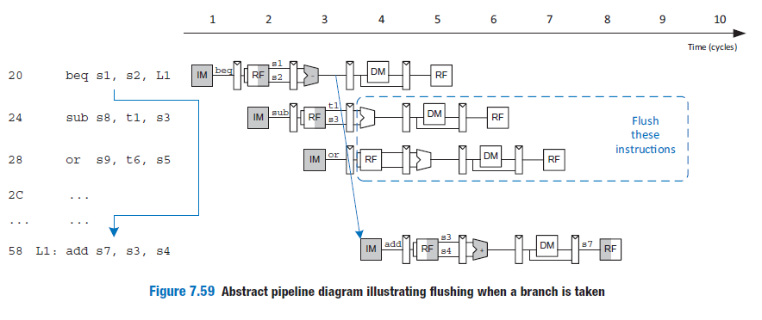

Q4: Consider the delays from Table 7.7 on page 415(book). Now, suppose that the ALU were 20% faster. Would the cycle time of the pipelined RISC-V processor change? What if the ALU were 20% slower? Explain your answers and show your work.
